|  |
| --- |
|  |

Specifying Software Requirements

Project: MDHMS: Military Dining Hall Management System

Tú

Revision 1

|  |  |  |
| --- | --- | --- |
|  |  | May |

.

Document file

|  |  |  |  |
| --- | --- | --- | --- |
| **Date** | **Revision** | **Author** | **Verified dep. quality.** |
| 25/5/2024 | Rev 1. | The Java Bandits |  |

Document validated by the parties on date: 25/05/2024

|  |  |
| --- | --- |
| By the customer | By the supplier company |
|  |  |
| Fdo. D./ Mrs. | Fdo. D./Dña |

Content

Document file 4

Content 5

1 Introduction 7

1.1 Purpose 7

1.2 Scope 7

1.3 Staff involved

1.4 Definitions, acronyms and abbreviations 7

1.5 References 7

1.6 Summary

2 Overview 8

2.1 Product Outlook 8

2.2 Product Functionality 8

2.3 User Features 8

2.4 Restrictions 8

2.5 Assumptions and dependencies

2.6 Foreseeable evolution of the system

3 Specific Requirements 8

3.1 Common Interface Requirements

3.1.1 User Interfaces

3.1.2 Hardware Interfaces

3.1.3 Software Interfaces

3.1.4 Communication Interfaces

3.2 Functional Requirements 9

3.2.1 Functional Requirement 1 9

3.2.2 Functional Requirement 2 10

3.2.3 Functional Requirement 3 10

3.2.4 Functional Requirement n

3.3 Non-functional requirements 10

3.3.1 Performance Requirements 10

3.3.2 Safety 10

3.3.3 Reliability 10

3.3.4 Availability 11

3.3.5 Maintainability 11

3.3.6 Portability 11

3.4 Other Requirements 11

4 Appendices 11

# Introduction

## Purpose

**Purpose of the document**

The purpose of this document is to define and specify the requirements for the development of a military dining hall management system (MDHMS) for the special forces brigade. This system aims to streamline canteen operations, enhance efficiency in meal management, and ensure secure and easy payment processes.

Target audience

The document is aimed at:

Software developers in charge of implementing the system.

Administrative staff of the brigade responsible for the management of the canteen.

Technical staff in charge of the integration of the system with banking and identification platforms.

## Scope

**Product Identification**

The product to be developed, known as the 'Military Dining Hall Management System' (MDHMS), will automate and enhance the management of the dining facilities within the special forces brigade. This system will handle meal registrations, electronic payments, and consumption reporting, ensuring alignment with the operational objectives and security protocols of the brigade.

Consistency with similar definitions of higher-level documents

This document is consistent with the definitions and guidelines set forth in the description of the Special Forces Brigade Dining Management System, ensuring alignment with organizational and operational objectives.

## Definitions, acronyms and abbreviations

MDHMS: Military Dining Hall Management System.

RF: Functional Requirement.

RNF: Non-functional requirement.

ID: Identification.

## References

|  |  |  |  |  |
| --- | --- | --- | --- | --- |
| **Reference** | **Title** | **Route** | **Date** | **Author** |
| [Ref1] | System Description | /path/description | 2024-05-01 | F.E. Brigade |
| [Ref2] | Safety Guidelines | /route/safety | 2024-05-15 | IT Dept. |
| [Ref3] | Banking Specifications | /route/bank | 2024-05-20 | XYZ Bank |

# Overview

## Product Outlook

The MDHMS is a standalone product designed to automate the canteen management process in the special forces brigade

## Product Functionality

The QMS should provide the following functionalities:

* Advance electronic payments.
* Digital record of food consumption.
* Automation of the daily registration of diners.
* Generation of consumption reports.
* Push notifications to users.

## User Features

|  |  |  |  |
| --- | --- | --- | --- |
| User Type | Military | Administrator | Technician |
| Formation | Basic and higher education | Higher education | Engineering or similar |
| Skills | Basic Device Usage | Systems & Data Management | Software Development & Maintenance |
| Activities | Consumption Registration, Electronic Payments | Consumption monitoring, reporting | System Implementation & Support |

## Restrictions

* Development methodologies: An agile methodology will be used.
* Programming languages: Languages such as Java and JavaScript will be preferred.
* Safety Standards: Compliance with brigade safety regulations.
* Hardware: The system must be compatible with standard mobile devices and workstations.
* Operating system: Compatible with Windows and Android.

# Specific Requirements

|  |  |  |  |
| --- | --- | --- | --- |
| Requirement Number | RF 1 | | |
| Requirement Name | Electronic Payments | | |
| Guy | Requirement | Restriction | |
| Source of Requirement | Administrative staff | | |
| Priority of the requirement | High/Essential | Medium/Desired | Low/Optional |

|  |  |  |  |
| --- | --- | --- | --- |
| Requirement Number | RF 2 | | |
| Requirement Name | Digital Consumption Record | | |
| Guy | Requirement | Restriction | |
| Source of Requirement | Administrative staff | | |
| Priority of the requirement | High/Essential | Medium/Desired | Low/Optional |

|  |  |  |  |
| --- | --- | --- | --- |
| Requirement Number | RF 3 | | |
| Requirement Name | Automation of daily logging | | |
| Guy | Requirement | Restriction | |
| Source of Requirement | Administrative staff | | |
| Priority of the requirement | High/Essential | Medium/Desired | Low/Optional |

|  |  |  |  |
| --- | --- | --- | --- |
| Requirement Number | RNF 1 | | |
| Requirement Name | Load Capacity | | |
| Guy | Requirement | Restriction | |
| Source of Requirement | Administrative staff | | |
| Priority of the requirement | High/Essential | Medium/Desired | Low/Optional |

|  |  |  |  |
| --- | --- | --- | --- |
| Requirement Number | RNF 2 | | |
| Requirement Name | Data Security | | |
| Guy | Requirement | Restriction | |
| Source of Requirement | Administrative staff | | |
| Priority of the requirement | High/Essential | Medium/Desired | Low/Optional |

|  |  |  |  |
| --- | --- | --- | --- |
| Requirement Number | RNF 3 | | |
| Requirement Name | Failure rate | | |
| Guy | Requirement | Restriction | |
| Source of Requirement | Administrative staff | | |
| Priority of the requirement | High/Essential | Medium/Desired | Low/Optional |

|  |  |  |  |
| --- | --- | --- | --- |
| Requirement Number | RNF 4 | | |
| Requirement Name | System Availability | | |
| Guy | Requirement | Restriction | |
| Source of Requirement | Administrative staff | | |
| Priority of the requirement | High/Essential | Medium/Desired | Low/Optional |

|  |  |  |  |
| --- | --- | --- | --- |
| Requirement Number | RNF 5 | | |
| Requirement Name | Ease of maintenance | | |
| Guy | Requirement | Restriction | |
| Source of Requirement | Administrative staff | | |
| Priority of the requirement | High/Essential | Medium/Desired | Low/Optional |

|  |  |  |  |
| --- | --- | --- | --- |
| Requirement Number | RNF 6 | | |
| Requirement Name | Software Portability | | |
| Guy | Requirement | Restriction | |
| Source of Requirement | Administrative staff | | |
| Priority of the requirement | High/Essential | Medium/Desired | Low/Optional |

## Functional Requirements

.

### Functional Requirement 1

* Requirement Number: RF 1
* Requirement Name: Electronic Payments
* Type: Requirement
* Requirement Source: Administrative Staff
* Requirement Priority: High
* Description: The system should allow users to make advance electronic payments through a mobile app or banking platform.

### Functional Requirement 2

* Requirement Number: RF 2
* Requirement Name: Digital Consumption Record
* Type: Requirement
* Requirement Source: Administrative Staff
* Requirement Priority: High
* Description: The system should allow users to record the days they will consume food one or two days in advance.

### Functional Requirement 3

* Requirement Number: RF 3
* Requirement Name: Daily Logging Automation
* Type: Requirement
* Requirement Source: Administrative Staff
* Requirement Priority: High
* Description: The system should automate the daily comparison, generating automatic reports on food consumption.

## Non-functional requirements

### Performance Requirements

* Performance Requirements
* Requirement Number: RNF 1
* Requirement Name: Load Capacity
* Type: Requirement
* Requirement Source: Technical Staff
* Requirement Priority: Medium
* Description: The system must support at least 200 users simultaneously, with response times of less than 2 seconds for 95% of transactions.

### Safety

* Requirement Number: RNF 2
* Requirement Name: Data Security
* Type: Requirement
* Requirement Source: IT Dept.
* Requirement Priority: High
* Description: The system must use cryptographic techniques to protect payment and consumption data, and perform regular audits to ensure the integrity of the system.

### Reliability

* Requirement Number: RNF 3
* Requirement Name: Failure Rate
* Type: Requirement
* Requirement Source: Technical Staff
* Requirement Priority: Medium
* Description: The system must have a failure rate of less than 0.1% per month.

### Availability

* Requirement Number: RNF 4
* Requirement Name: System Availability
* Type: Requirement
* Requirement Source: Technical Staff
* Requirement Priority: High
* Description: The system must be available 99.5% of the time, with a maximum downtime of no more than 3 hours per month.

### Maintainability

* Requirement Number: RNF 5
* Requirement Name: Ease of Maintenance
* Type: Requirement
* Requirement Source: Technical Staff
* Requirement Priority: Medium
* Description: The system must allow maintenance by trained technical personnel, with scheduled maintenance tasks to avoid interruptions during operating hours.

### Portability

* Requirement Number: RNF 6
* Requirement Name: Software Portability
* Type: Requirement
* Requirement Source: Technical Staff
* Requirement Priority: Medium
* Description: The system must be portable to other platforms, with 80% of the code independent of the server and developed in portable languages such as Java.

## Other Requirements

# Appendices

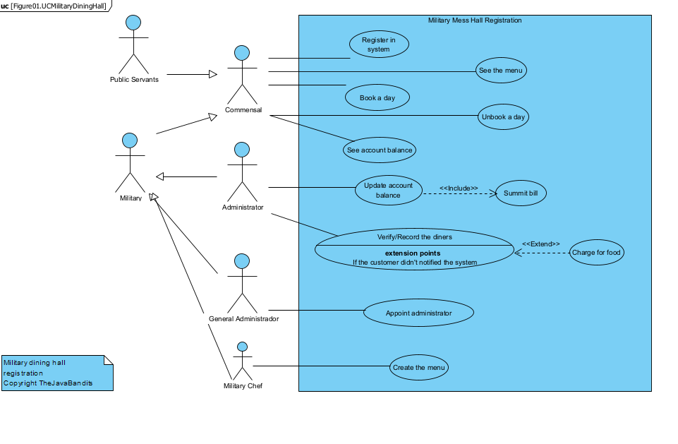

Figure 1: 1 Use case diagram